**PMCA503P DATABASE SYSTEM LAB**

**CYCLE SHEET – 1**

**Consider the following relational database schema for teaching-learning process in a university.**

**(Source: Database Systems – Coronel & Morris)**

**PROFESSOR(Prof_id, Prof_name, Email, Mobile, Specialty, Dept_id)**

**SCHOOL(SCode, Scl_name, Prof_id, Location)**

**DEPARTMENT(Dept_id, Dname, SCode, Prof_id)**

**COURSE(Crs_code, Crs_name, Description, Credits, Hours)**

**CLASS(Cls_code, Slot, Stime, Etime, Crs_code, Prof_id, Room_no, Sem_code, Day_of_week)**

**SEMESTER(Sem_code, Term, Year, Sdate, Edate)**

**STUDENT(Reg_no, Sname, Address, DoB, Email, Mobile, Dept_id, Prof_id)**

**ENROLL(Cls_code, Reg_no, Enroll_time, Grade)**

**STUDENT_VISA(Reg_no, Visa_status)**

**PROGRAMME(Prog_code, Prog_name, Prog_preamble, Scode, Dept_id)**

**The primary keys are underlined and foreign keys are self-explanatory. The Dept_id column in**

**professor table stands for the department the professor belongs to and Prof_id column in the**

**school table stands for the professor who chairs the school, the same column in the department**

**table stands for the professor who heads the department, the domain of Term column in semester**

**table is {Winter, Fall}**

**Q1. Create the above tables.**

**Q2. Enter data into the above tables. (Learn how to enter data interactively also.). Display the**

**content of each table. Use column formatting while displaying.**

**-- TABLES**

create table PROFESSOR(Prof_id char(5), Prof_name varchar(20), Email varchar(25), Mobile varchar(10), Speciality varchar(12), Dept_id varchar(5));

create table SCHOOL(SCode varchar(5), Scl_name varchar(20), Prof_id char(5), Location varchar(15));

create table DEPARTMENT(Dept_id varchar(5), Dname varchar(15), SCode varchar(7), Prof_id char(5));

create table COURSE(Crs_code varchar(5), Crs_name varchar(18), Description varchar(30), Credits number(2), Hours number(3));

create table CLASS(Cls_code varchar(21), Slot varchar(10), Stime timestamp, Etime timestamp, Crs_code varchar(5), Prof_id char(5), Room_no number(3), Sem_code varchar(8), Day_of_week varchar(7));

create table SEMESTER(Sem_code varchar(7), Term varchar(6), Year varchar(7), Sdate date, Edate date);

create table STUDENT(Reg_no varchar(11), Sname varchar(15), Address varchar(25), DoB date, Email varchar(25), Mobile varchar(10), Dept_id varchar(5), Prof_id char(5));

create table ENROLL(Cls_code varchar(12), Reg_no varchar(11), Enroll_time timestamp, Grade char(1));

create table STUDENT_VISA(Reg_no varchar(11), Visa_status varchar(10));

create table PROGRAMME(Prog_code varchar(5), Prog_name varchar(10), Prog_preamble varchar(40), Scode varchar(5), Dept_id varchar(5));

**--  Q3 Alter or Recreate the above tables with primary key and foreign key and the following**

**integrity constraints assigning name to integrity constraint**

**-- PRIMARY KEYS**

alter table PROFESSOR add constraint prof_id_pk primary key(Prof_id);

alter table SCHOOL add constraint scode_pk primary key(SCode);

alter table DEPARTMENT add constraint dept_id_pk primary key(Dept_id);

alter table COURSE add constraint crs_code_pk primary key(Scode);

alter table CLASS add constraint cls_code_pk primary key(Cls_code);

alter table SEMESTER add constraint sem_code_pk primary key(Sem_code);

alter table STUDENT add constraint reg_no_pk primary key(Reg_no);

alter table ENROLL add constraint cls_n_reg_no_pk primary key(Cls_code, Reg_no);

alter table STUDENT_VISA add constraint sv_reg_no_pk primary key(Reg_no);

alter table PROGRAMME add constraint prog_code_pk primary key(Prog_code);

**-- FOREIGN KEY**

alter table PROFESSOR add constraint fk_professor_dept_id foreign key (Dept_id) refrences DEPARTMENT(Dept_id) deferrable initially deferred;

alter table SCHOOL add constraint sc_p_id_fk foreign key(Prof_id) refrences PROFESSOR(Prof_id);

alter table DEPARTMENT add constraint dept_SCode_fk foreign key(SCode) refrences SCHOOL(SCode);

alter table DEPARTMENT add constraint dept_p_id_fk foreign key(Prof_id) refrences PROFESSOR(Prof_id) deferrable initially deferred;

alter table CLASS add constraint cl_p_id_fk foreign key(Prof_id) refrences PROFESSOR(Prof_id);

alter table CLASS add constraint cl_sem_code_fk foreign key(Sem_code) refrences SEMESTER(Sem_Code);

alter table CLASS add constraint cl_crs_code_fk foreign key(Crs_code) refrences COURSE(Crs_code);

alter table STUDENT add constraint stu_p_id_fk foreign key(Prof_id) refrences PROFESSOR(Prof_id);

alter table STUDENT add constraint stu_dept_id_fk foreign key(Dept_id) refrences DEPARTMENT(Dept_id) deferrable initially deferred;

alter table ENROLL add constraint en_cls_code_fk foreign key(Cls_code) refrences CLASS(Cls_code);

alter table ENROLL add constraint en_reg_no_fk foreign key(Reg_no) refrences STUDENT(Reg_no);

alter table STUDENT_VISA add constraint sv_reg_no_fk foreign key(Reg_no) refrences STUDENT(Reg_no);

alter table PROGRAMME add constraint prog_dept_id_fk foreign key(Dept_id) refrences DEPARTMENT(Dept_id);

alter table PROGRAMME add constraint prog_SCode_fk foreign key(Scode) refrences SCHOOL(SCode);

**--i) Prof_id must have exactly five characters and their email and mobile number are unique. The email address must have @ as one of the characters and mobile number must have exactly ten characters.**

alter table PROFESSOR add constraint pf_id_ck check(length(Prof_id)=5);

alter table PROFESSOR add constraint pf_email_ck check(Email like '%@%');

alter table PROFESSOR add constraint pf_mobile_len check(length(Mobile)=10);

alter table PROFESSOR add constraint pf_mobile_unq UNIQUE(Mobile);

**--ii) Use timestamp data type without fractional parts of seconds for start time and end time column of class table.**

alter table CLASS add constraint stime_ck check(EXTRACT(MILLISECOND FROM Stime)=0);

alter table CLASS add constraint etime_ck check(EXTRACT(MILLISECOND FROM Etime)=0);

**--iii) The Sem_code should start with either ‘Win’ or ‘Fall’ and Term column can assume only one of two values {Winter, Fall}.**

alter table SEMESTER add constraint sem_code_ck check(Sem_code like 'Win%' or Sem_code like 'Fall%');

alter table SEMESTER add constraint term_ck check(Term in ('Winter', 'Fall'));

**--iv) Email and mobile column in student table should have same characteristics as those in professor table.**

alter table STUDENT add constraint st_email_ck check(Email like '%@%');

alter table STUDENT add constraint st_mobile_len check(length(Mobile)=10);

alter table STUDENT add constraint st_mobile_unq UNIQUE(Mobile);

**--v) The enroll_time in the enroll table should be of timestamp data type without fractional parts of seconds. The grade may assume one of the values in {‘S’, ‘A’, ‘B’, ‘C’, ‘D’}**

alter table ENROLL add constraint grade_ck check(Grade in ('S', 'A', 'B', 'C', 'D'));

**--Insert**

INSERT INTO PROFESSOR VALUES ('PMT01', 'Albert Smith', 'albert@uni.edu', '9876543210','Maths' , 'DEPMT');

INSERT INTO PROFESSOR VALUES ('PMT02', 'Linda R', 'linda.r@uni.edu', '9876003210', 'Maths', 'DEPMT');

INSERT INTO PROFESSOR VALUES ('PPY01', 'Barney Johnson', 'barney.j@uni.edu', NULL, 'Physics', 'DEPPY');

INSERT INTO PROFESSOR VALUES ('PPY02', 'Ted Morsby', 'ted.m@uni.edu', '6547891234', 'Physics', 'DEPPY');

INSERT INTO PROFESSOR VALUES ('PCH01', 'Carl White', 'carl.w@uni.edu', '7654321098', 'Chemistry', 'DEPCH');

INSERT INTO PROFESSOR VALUES ('PCH02', 'David Miller', 'david.m@uni.edu', '9879876543', 'Chemistry', 'DEPCH');

INSERT INTO PROFESSOR VALUES ('PMD01', 'Dave Brown', 'dave.b@uni.edu', NULL, 'Medicine', 'DEPMD');

INSERT INTO PROFESSOR VALUES ('PMD02', 'Ivian Adams', 'ivian.a@uni.edu', '1098765432', 'Medicine', 'DEPMD');

INSERT INTO PROFESSOR VALUES ('PHT01', 'Elsa Green', 'elsa.g@uni.edu', '5432109876','History', 'DEPHT');

INSERT INTO PROFESSOR VALUES ('PHT02', 'Jenny Martin', 'jenny.m@uni.edu', '9087654321', 'History', 'DEPHT');

INSERT INTO PROFESSOR VALUES ('POS01', 'Rakesh Kumar', 'rakesh.k@uni.edu', '8076543210', 'OS', 'DEPOS');

INSERT INTO PROFESSOR VALUES ('POS02', 'Donna Carter', 'donna.c@uni.edu', '6054321098', 'OS', 'DEPOS');

INSERT INTO PROFESSOR VALUES ('PDB01', 'Henry Baker', 'henry.b@uni.edu', '7065432109', 'Database', 'DEPDB');

INSERT INTO PROFESSOR VALUES ('PDB02', 'Sam Wilson', 'sam.w@uni.edu', '5043210987', 'Database', 'DEPDB');

INSERT INTO PROFESSOR VALUES ('PDB03', 'Lily Scott', 'lily.s@uni.edu', '4032109876', 'Database', 'DEPDB');

INSERT INTO SCHOOL VALUES ('SCSCI', 'Science School', 'PCH02', 'Science Block');

INSERT INTO SCHOOL VALUES ('SCMED', 'Medicine School', 'PPY02', 'Medicine Block');

INSERT INTO SCHOOL VALUES ('SCART', 'Arts School', 'PHT02', 'Arts Block');

INSERT INTO SCHOOL VALUES ('SCTEC', 'Tech School', 'PDB02', 'Tech Block');

INSERT INTO DEPARTMENT VALUES ('DEPMT', 'Math Dept', 'SCSCI', 'PMT01');

INSERT INTO DEPARTMENT VALUES ('DEPPY', 'Physics Dept', 'SCSCI', 'PPY01');

INSERT INTO DEPARTMENT VALUES ('DEPCH', 'Chemistry Dept', 'SCSCI', 'PCH01');

INSERT INTO DEPARTMENT VALUES ('DEPMD', 'Medicine Dept', 'SCMED', 'PMD01');

INSERT INTO DEPARTMENT VALUES ('DEPHT', 'History Dept', 'SCART', 'PHT01');

INSERT INTO DEPARTMENT VALUES ('DEPOS', 'OS Dept', 'SCTEC', 'POS01');

INSERT INTO DEPARTMENT VALUES ('DEPDB', 'Database Dept', 'SCTEC', 'PDB01');

INSERT INTO COURSE VALUES ('CRMT1', 'Intro to Math', 'Basic concepts of mathematics', 4, 40);

INSERT INTO COURSE VALUES ('CRPY1', 'Basic Physics', 'Principles modern physics', 3, 30);

INSERT INTO COURSE VALUES ('CRPY2', 'Advanced Physics', 'Principles modern physics', 4, 40);

INSERT INTO COURSE VALUES ('CRCH1', 'Advanced Chem', 'In-depth study of reactions', 4, 40);

INSERT INTO COURSE VALUES ('CRBI1', 'Bio Research', 'Techniques for Bio research', 4, 40);

INSERT INTO COURSE VALUES ('CRHT1', 'Ancient History', 'Methods of historical research', 4, 40);

INSERT INTO COURSE VALUES ('CROS1', 'Operating Systems', 'Understanding OS', 4, 40);

INSERT INTO COURSE VALUES ('CRDB1', 'Database System', 'Methods of DBMS', 4, 40);

INSERT INTO COURSE VALUES ('CRDB2', 'Database Basics', 'Basics of DBMS', 3, 30);

INSERT INTO SEMESTER VALUES ('FAL1617', 'Fall', '2016', TO_DATE('2016-07-01', 'YYYY-MM-DD'), TO_DATE('2016-11-15', 'YYYY-MM-DD'));

INSERT INTO SEMESTER VALUES ('WIN1617', 'Winter', '2016', TO_DATE('2016-12-15', 'YYYY-MM-DD'), TO_DATE('2017-05-15', 'YYYY-MM-DD'));

INSERT INTO SEMESTER VALUES ('FAL1718', 'Fall', '2017', TO_DATE('2017-07-01', 'YYYY-MM-DD'), TO_DATE('2017-11-15', 'YYYY-MM-DD'));

INSERT INTO SEMESTER VALUES ('WIN1718', 'Winter', '2017', TO_DATE('2017-12-15', 'YYYY-MM-DD'), TO_DATE('2018-05-15', 'YYYY-MM-DD'));

-- Fall 2016 Semester

INSERT INTO CLASS VALUES ('ClsFMat16MWF', 'Morning', TO_TIMESTAMP('09:00:00', 'HH24:MI:SS'), TO_TIMESTAMP('10:30:00', 'HH24:MI:SS'), 'CRMT1', 'PMT01', 101, 'FAL1617', 'MWF');

INSERT INTO CLASS VALUES ('ClsFPhy16TTh', 'Afternoon', TO_TIMESTAMP('14:00:00', 'HH24:MI:SS'), TO_TIMESTAMP('15:30:00', 'HH24:MI:SS'), 'CRHT1', 'PPY01', 102, 'FAL1617', 'TTh');

INSERT INTO CLASS VALUES ('ClsFChe16MWF', 'Evening', TO_TIMESTAMP('17:00:00', 'HH24:MI:SS'), TO_TIMESTAMP('18:30:00', 'HH24:MI:SS'), 'CRCH1', 'PCH01', 103, 'FAL1617', 'MWF');

INSERT INTO CLASS VALUES ('ClsFBio16TTh', 'Morning', TO_TIMESTAMP('08:00:00', 'HH24:MI:SS'), TO_TIMESTAMP('09:30:00', 'HH24:MI:SS'), 'CRBI1', 'PMD01', 104, 'FAL1617', 'TTh');

INSERT INTO CLASS VALUES ('ClsFHis16MWF', 'Afternoon', TO_TIMESTAMP('13:00:00', 'HH24:MI:SS'), TO_TIMESTAMP('14:30:00', 'HH24:MI:SS'), 'CRHT1', 'PHT01', 105, 'FAL1617', 'MWF');

INSERT INTO CLASS VALUES ('ClsF0OS16MWF', 'Evening', TO_TIMESTAMP('16:00:00', 'HH24:MI:SS'), TO_TIMESTAMP('17:30:00', 'HH24:MI:SS'), 'CROS1', 'POS01', 106, 'FAL1617', 'MWF');

INSERT INTO CLASS VALUES ('ClsF0DB16TTh', 'Morning', TO_TIMESTAMP('10:00:00', 'HH24:MI:SS'), TO_TIMESTAMP('11:30:00', 'HH24:MI:SS'), 'CRDB1', 'PDB03', 107, 'FAL1617', 'TTh');

INSERT INTO CLASS VALUES ('ClsFDBB16MWF', 'Afternoon', TO_TIMESTAMP('14:00:00', 'HH24:MI:SS'), TO_TIMESTAMP('15:30:00', 'HH24:MI:SS'), 'CRDB2', 'PDB03', 108, 'FAL1617', 'MWF');

-- Winter 2016 Semester

INSERT INTO CLASS VALUES ('ClsWMat16MWF', 'Morning', TO_TIMESTAMP('09:00:00', 'HH24:MI:SS'), TO_TIMESTAMP('10:30:00', 'HH24:MI:SS'), 'CRMT1', 'PMT02', 201, 'WIN1617', 'MWF');

INSERT INTO CLASS VALUES ('ClsWPhy16TTh', 'Afternoon', TO_TIMESTAMP('14:00:00', 'HH24:MI:SS'), TO_TIMESTAMP('15:30:00', 'HH24:MI:SS'), 'CRHT1', 'PPY02', 202, 'WIN1617', 'TTh');

INSERT INTO CLASS VALUES ('ClsWChe16MWF', 'Evening', TO_TIMESTAMP('17:00:00', 'HH24:MI:SS'), TO_TIMESTAMP('18:30:00', 'HH24:MI:SS'), 'CRCH1', 'PCH02', 203, 'WIN1617', 'MWF');

INSERT INTO CLASS VALUES ('ClsWBio16TTh', 'Morning', TO_TIMESTAMP('08:00:00', 'HH24:MI:SS'), TO_TIMESTAMP('09:30:00', 'HH24:MI:SS'), 'CRBI1', 'PMD02', 204, 'WIN1617', 'TTh');

INSERT INTO CLASS VALUES ('ClsWHis16MWF', 'Afternoon', TO_TIMESTAMP('13:00:00', 'HH24:MI:SS'), TO_TIMESTAMP('14:30:00', 'HH24:MI:SS'), 'CRHT1', 'PHT02', 205, 'WIN1617', 'MWF');

INSERT INTO CLASS VALUES ('ClsW0OS16MWF', 'Evening', TO_TIMESTAMP('16:00:00', 'HH24:MI:SS'), TO_TIMESTAMP('17:30:00', 'HH24:MI:SS'), 'CROS1', 'POS02', 206, 'WIN1617', 'MWF');

INSERT INTO CLASS VALUES ('ClsW0DB16TTh', 'Morning', TO_TIMESTAMP('10:00:00', 'HH24:MI:SS'), TO_TIMESTAMP('11:30:00', 'HH24:MI:SS'), 'CRDB1', 'PDB03', 207, 'WIN1617', 'TTh');

INSERT INTO CLASS VALUES ('ClsWDBB16MWF', 'Afternoon', TO_TIMESTAMP('14:00:00', 'HH24:MI:SS'), TO_TIMESTAMP('15:30:00', 'HH24:MI:SS'), 'CRDB2', 'PDB03', 208, 'WIN1617', 'MWF');

-- Fall 2017 Semester

INSERT INTO CLASS VALUES ('ClsFMat17MWF', 'Morning', TO_TIMESTAMP('09:00:00', 'HH24:MI:SS'), TO_TIMESTAMP('10:30:00', 'HH24:MI:SS'), 'CRMT1', 'PMT02', 301, 'FAL1718', 'MWF');

INSERT INTO CLASS VALUES ('ClsFPhy17TTh', 'Afternoon', TO_TIMESTAMP('14:00:00', 'HH24:MI:SS'), TO_TIMESTAMP('15:30:00', 'HH24:MI:SS'), 'CRHT1', 'PPY01', 302, 'FAL1718', 'TTh');

INSERT INTO CLASS VALUES ('ClsFChe17MWF', 'Evening', TO_TIMESTAMP('17:00:00', 'HH24:MI:SS'), TO_TIMESTAMP('18:30:00', 'HH24:MI:SS'), 'CRCH1', 'PCH02', 303, 'FAL1718', 'MWF');

INSERT INTO CLASS VALUES ('ClsFBio17TTh', 'Morning', TO_TIMESTAMP('08:00:00', 'HH24:MI:SS'), TO_TIMESTAMP('09:30:00', 'HH24:MI:SS'), 'CRBI1', 'PMD01', 304, 'FAL1718', 'TTh');

INSERT INTO CLASS VALUES ('ClsFHis17MWF', 'Afternoon', TO_TIMESTAMP('13:00:00', 'HH24:MI:SS'), TO_TIMESTAMP('14:30:00', 'HH24:MI:SS'), 'CRHT1', 'PHT02', 305, 'FAL1718', 'MWF');

INSERT INTO CLASS VALUES ('ClsF0OS17MWF', 'Evening', TO_TIMESTAMP('16:00:00', 'HH24:MI:SS'), TO_TIMESTAMP('17:30:00', 'HH24:MI:SS'), 'CROS1', 'POS01', 306, 'FAL1718', 'MWF');

INSERT INTO CLASS VALUES ('ClsF0DB17TTh', 'Morning', TO_TIMESTAMP('10:00:00', 'HH24:MI:SS'), TO_TIMESTAMP('11:30:00', 'HH24:MI:SS'), 'CRDB1', 'PDB01', 307, 'FAL1718', 'TTh');

INSERT INTO CLASS VALUES ('ClsFDBB17MWF', 'Afternoon', TO_TIMESTAMP('14:00:00', 'HH24:MI:SS'), TO_TIMESTAMP('15:30:00', 'HH24:MI:SS'), 'CRDB2', 'PDB03', 308, 'FAL1718', 'MWF');

-- Winter 2017 Semester

INSERT INTO CLASS VALUES ('ClsWMat17MWF', 'Morning', TO_TIMESTAMP('09:00:00', 'HH24:MI:SS'), TO_TIMESTAMP('10:30:00', 'HH24:MI:SS'), 'CRMT1', 'PMT01', 401, 'WIN1718', 'MWF');

INSERT INTO CLASS VALUES ('ClsWPhy17TTh', 'Afternoon', TO_TIMESTAMP('14:00:00', 'HH24:MI:SS'), TO_TIMESTAMP('15:30:00', 'HH24:MI:SS'), 'CRHT1', 'PPY02', 402, 'WIN1718', 'TTh');

INSERT INTO CLASS VALUES ('ClsWChe17MWF', 'Evening', TO_TIMESTAMP('17:00:00', 'HH24:MI:SS'), TO_TIMESTAMP('18:30:00', 'HH24:MI:SS'), 'CRCH1', 'PCH01', 403, 'WIN1718', 'MWF');

INSERT INTO CLASS VALUES ('ClsWBio17TTh', 'Morning', TO_TIMESTAMP('08:00:00', 'HH24:MI:SS'), TO_TIMESTAMP('09:30:00', 'HH24:MI:SS'), 'CRBI1', 'PMD02', 404, 'WIN1718', 'TTh');

INSERT INTO CLASS VALUES ('ClsWHis17MWF', 'Afternoon', TO_TIMESTAMP('13:00:00', 'HH24:MI:SS'), TO_TIMESTAMP('14:30:00', 'HH24:MI:SS'), 'CRHT1', 'PHT02', 305, 'WIN1718', 'MWF');

INSERT INTO CLASS VALUES ('ClsW0OS17MWF', 'Evening', TO_TIMESTAMP('16:00:00', 'HH24:MI:SS'), TO_TIMESTAMP('17:30:00', 'HH24:MI:SS'), 'CROS1', 'POS01', 306, 'WIN1718', 'MWF');

INSERT INTO CLASS VALUES ('ClsW0DB17TTh', 'Morning', TO_TIMESTAMP('10:00:00', 'HH24:MI:SS'), TO_TIMESTAMP('11:30:00', 'HH24:MI:SS'), 'CRDB1', 'PDB01', 307, 'WIN1718', 'TTh');

INSERT INTO CLASS VALUES ('ClsWDBB17MWF', 'Afternoon', TO_TIMESTAMP('14:00:00', 'HH24:MI:SS'), TO_TIMESTAMP('15:30:00', 'HH24:MI:SS'), 'CRDB2', 'PDB03', 308, 'WIN1718', 'MWF');

-- For 2016

INSERT INTO STUDENT VALUES ('S16MScM001', 'Sunil Gavaskar', '123 Dadar, Mumbai', TO_DATE('2002-05-15', 'YYYY-MM-DD'), 'sunil.g@uni.in', '9876543210', 'DEPMT', 'PMT01');

INSERT INTO STUDENT VALUES ('S16MScM002', 'Kapil Dev', '789 Sector 15, Chandigarh', TO_DATE('2001-06-15', 'YYYY-MM-DD'), 'kapil.d@uni.in', '9876543211', 'DEPMT', 'PMT02');

INSERT INTO STUDENT VALUES ('S16MScM003', 'Mohinder A', '321 Civil Lines, Delhi', TO_DATE('2002-08-25', 'YYYY-MM-DD'), 'mohinder.a@uni.in', '9876543212', 'DEPMT', 'PMT02');

INSERT INTO STUDENT VALUES ('S16MScP001', 'Dilip V', '456 Colaba, Mumbai', TO_DATE('2003-07-20', 'YYYY-MM-DD'), 'dilip.v@uni.in', '9876543213', 'DEPPY', 'PPY02');

INSERT INTO STUDENT VALUES ('S16MScP002', 'Syed Kirmani', '654 Basavanagudi, Indore', TO_DATE('2002-05-10', 'YYYY-MM-DD'), 'syed.k@uni.in', '9876543214', 'DEPPY', 'PPY02');

INSERT INTO STUDENT VALUES ('S16MScP003', 'Gundappa V', '987 Jayanagar, Bangalore', TO_DATE('2003-09-20', 'YYYY-MM-DD'), 'gundappa.v@uni.in', '9876543215', 'DEPPY', 'PPY01');

INSERT INTO STUDENT VALUES ('S16MScC001', 'Bishan Bedi', '7 Katpadi, Vellore', TO_DATE('2001-03-22', 'YYYY-MM-DD'), 'bishan.b@uni.in', '9876543216', 'DEPCH', 'PCH01');

INSERT INTO STUDENT VALUES ('S16MScC002', 'Madan Lal', '135 Ashok Nagar, Delhi', TO_DATE('2001-11-05', 'YYYY-MM-DD'), 'madan.l@uni.in', '9876543217', 'DEPCH', 'PCH02');

INSERT INTO STUDENT VALUES ('S16MScC003', 'Sandeep Patil', '246 Worli, Mumbai', TO_DATE('2002-07-30', 'YYYY-MM-DD'), 'sandeep.p@uni.in', '9876543218', 'DEPCH', 'PCH01');

INSERT INTO STUDENT VALUES ('S16MMed001', 'Ravi Shastri', 'Tamil Nadu', TO_DATE('2000-12-11', 'YYYY-MM-DD'), 'ravi.s@uni.in', '9876543219', 'DEPMD', 'PMD02');

INSERT INTO STUDENT VALUES ('S16MMed002', 'Kris Srikkanth', '468 Mylapore, Chennai', TO_DATE('2001-02-22', 'YYYY-MM-DD'), 'kris.s@uni.in', '9876543220', 'DEPMD', 'PMD02');

INSERT INTO STUDENT VALUES ('S16MMed003', 'Maninder Singh', '579 Sector 9, Chandigarh', TO_DATE('2000-04-18', 'YYYY-MM-DD'), 'maninder.s@uni.in', '9876543221', 'DEPMD', 'PMD01');

INSERT INTO STUDENT VALUES ('S16MA00001', 'Anshuman', '246 Navrangpura, Agra', TO_DATE('2002-09-30', 'YYYY-MM-DD'), 'anshuman.g@uni.in', '9876543222', 'DEPHT', 'PHT01');

INSERT INTO STUDENT VALUES ('S16MA00002', 'Eknath Solkar', '680 Churchgate, Mumbai', TO_DATE('2003-12-05', 'YYYY-MM-DD'), 'eknath.s@uni.in', '9876543223', 'DEPHT', 'PHT02');

INSERT INTO STUDENT VALUES ('S16MA00003', 'Chetan Chauhan', '791 Defence Colony, Delhi', TO_DATE('2004-01-25', 'YYYY-MM-DD'), 'chetan.c@uni.in', '9876543224', 'DEPHT', 'PHT02');

INSERT INTO STUDENT VALUES ('S16MCA0001', 'Kiran More', '357 GIDC, Baroda', TO_DATE('2004-11-05', 'YYYY-MM-DD'), 'kiran.m@uni.in', '9876543225', 'DEPOS', 'POS01');

INSERT INTO STUDENT VALUES ('S16MCA0002', 'Vinoo Mankad', '802 Ellis, Ahmedabad', TO_DATE('2003-03-15', 'YYYY-MM-DD'), 'vinoo.m@uni.in', '9876543226', 'DEPOS', 'POS02');

INSERT INTO STUDENT VALUES ('S16MCA0003', 'Ajit Wadekar', '913 Shivaji Park, Mumbai', TO_DATE('2004-04-30', 'YYYY-MM-DD'), 'ajit.w@uni.in', '9876543227', 'DEPOS', 'POS01');

INSERT INTO STUDENT VALUES ('S16MTech001', 'Farokh Engineer', '468 Katpadi, Vellore', TO_DATE('2003-01-18', 'YYYY-MM-DD'), 'farokh.e@uni.in', '9876543228', 'DEPDB', 'PDB01');

INSERT INTO STUDENT VALUES ('S16MTech002', 'Vishwanath', '124 Lion Road, Bangalore', TO_DATE('2002-08-14', 'YYYY-MM-DD'), 'vishwanath@uni.in', '9876543229', 'DEPDB', 'PDB02');

INSERT INTO STUDENT VALUES ('S16MTech003', 'Ajay Jadeja', '235 Sadar, Rajkot', TO_DATE('2003-10-25', 'YYYY-MM-DD'), 'ajay.j@uni.in', '9876543230', 'DEPDB', 'PDB03');

-- For 2017

INSERT INTO STUDENT VALUES ('S17MScM001', 'Virat Kohli', '789 MG Road, Delhi', TO_DATE('2001-06-15', 'YYYY-MM-DD'), 'virat.kohli@uni.edu', '9123456781', 'DEPMT', 'PMT01');

INSERT INTO STUDENT VALUES ('S17MScM002', 'Rohit Sharma', '321 Brigade Road, Mumbai', TO_DATE('2002-08-25', 'YYYY-MM-DD'), 'rohit.sharma@uni.edu', '9123456782', 'DEPMT', 'PMT02');

INSERT INTO STUDENT VALUES ('S17MScM003', 'Shikhar Dhawan', '654, Katpadi, Tamil Nadu', TO_DATE('2002-05-10', 'YYYY-MM-DD'), 'shikhar.dhawan@uni.edu', '9123456783', 'DEPMT', 'PMT01');

INSERT INTO STUDENT VALUES ('S17MScP001', 'Hardik Pandya', '987 Cedar Avenue, Baroda', TO_DATE('2003-09-20', 'YYYY-MM-DD'), 'hardik.pandya@uni.edu', '9234567891', 'DEPPY', 'PPY02');

INSERT INTO STUDENT VALUES ('S17MScP002', 'Jasprit Bumrah', '135, Katpadi, Tamil Nadu', TO_DATE('2002-11-05', 'YYYY-MM-DD'), 'jasprit.bumrah@uni.edu', '9234567892', 'DEPPY', 'PPY01');

INSERT INTO STUDENT VALUES ('S17MScP003', 'KL Rahul', '246 Oak Avenue, Bangalore', TO_DATE('2002-07-30', 'YYYY-MM-DD'), 'kl.rahul@uni.edu', '9234567893', 'DEPPY', 'PPY01');

INSERT INTO STUDENT VALUES ('S17MScC001', 'Ravindra Jadeja', '468 Maple Street, Rajkot', TO_DATE('2001-02-22', 'YYYY-MM-DD'), 'ravindra.jadeja@uni.edu', '9345678901', 'DEPCH', 'PCH02');

INSERT INTO STUDENT VALUES ('S17MScC002', 'Ravi Ashwin', '579 Cedar Avenue, Chennai', TO_DATE('2000-04-18', 'YYYY-MM-DD'), 'ravi.ashwin@uni.edu', '9345678902', 'DEPCH', 'PCH01');

INSERT INTO STUDENT VALUES ('S17MScC003', 'Bhuvi Kumar', '680 Maple Street, Meerut', TO_DATE('2003-12-05', 'YYYY-MM-DD'), 'bhuvneshwar.kumar@uni.edu', '9345678903', 'DEPCH', 'PCH01');

INSERT INTO STUDENT VALUES ('S17MMed001', 'MS Dhoni', '791 Pine Avenue, Ranchi', TO_DATE('2004-01-25', 'YYYY-MM-DD'), 'ms.dhoni@uni.edu', '9456789012', 'DEPMD', 'PMD02');

INSERT INTO STUDENT VALUES ('S17MMed002', 'Yuvraj Singh', '802 Birch, Chandigarh', TO_DATE('2003-03-15', 'YYYY-MM-DD'), 'yuvraj.singh@uni.edu', '9456789013', 'DEPMD', 'PMD01');

INSERT INTO STUDENT VALUES ('S17MMed003', 'Suresh Raina', '913, Katpadi, Tamil Nadu', TO_DATE('2004-04-30', 'YYYY-MM-DD'), 'suresh.raina@uni.edu', '9456789014', 'DEPMD', 'PMD02');

INSERT INTO STUDENT VALUES ('S17MA00001', 'Ajinkya Rahane', '124 Oak Street, Mumbai', TO_DATE('2002-08-14', 'YYYY-MM-DD'), 'ajinkya.rahane@uni.edu', '9567890123', 'DEPHT', 'PHT01');

INSERT INTO STUDENT VALUES ('S17MA00002', 'Shubman Gill', '235 Maple Avenue, Mohali', TO_DATE('2003-10-25', 'YYYY-MM-DD'), 'shubman.gill@uni.edu', '9567890124', 'DEPHT', 'PHT02');

INSERT INTO STUDENT VALUES ('S17MA00003', 'Mohammed Shami', '579 Birch Street, Amroha', TO_DATE('2004-11-05', 'YYYY-MM-DD'), 'mohammed.shami@uni.edu', '9567890125', 'DEPHT', 'PHT02');

INSERT INTO STUDENT VALUES ('S17MCA0001', 'Rishabh Pant', '913 Cedar Street, Delhi', TO_DATE('2004-04-30', 'YYYY-MM-DD'), 'rishabh.pant@uni.edu', '9678901234', 'DEPOS', 'POS01');

INSERT INTO STUDENT VALUES ('S17MCA0002', 'Ishan Kishan', '357 Birch Avenue, Patna', TO_DATE('2003-03-15', 'YYYY-MM-DD'), 'ishan.kishan@uni.edu', '9678901235', 'DEPOS', 'POS02');

INSERT INTO STUDENT VALUES ('S17MCA0003', 'Shreyas Iyer', '246, Katpadi, Tamil Nadu', TO_DATE('2004-01-18', 'YYYY-MM-DD'), 'shreyas.iyer@uni.edu', '9678901236', 'DEPOS', 'POS01');

INSERT INTO STUDENT VALUES ('S17MTech001', 'Axar Patel', '357 Birch Avenue, Anand', TO_DATE('2004-11-05', 'YYYY-MM-DD'), 'axar.patel@uni.edu', '9789012345', 'DEPDB', 'PDB01');

INSERT INTO STUDENT VALUES ('S17MTech002', 'Prithvi Shaw', '680 Maple Avenue, Mumbai', TO_DATE('2003-03-15', 'YYYY-MM-DD'), 'prithvi.shaw@uni.edu', '9789012346', 'DEPDB', 'PDB02');

INSERT INTO STUDENT VALUES ('S17MTech003', 'Washington S', '124, Katpadi, Tamil Nadu', TO_DATE('2002-08-14', 'YYYY-MM-DD'), 'washington.sundar@uni.edu', '9789012347', 'DEPDB', 'PDB03');

-- For 2016

INSERT INTO ENROLL VALUES ('ClsFMat16MWF', 'S16MScM001', TO_TIMESTAMP('2016-05-01 09:00:00', 'YYYY-MM-DD HH24:MI:SS'), 'A');

INSERT INTO ENROLL VALUES ('ClsWMat16MWF', 'S16MScM002', TO_TIMESTAMP('2016-11-01 09:00:00', 'YYYY-MM-DD HH24:MI:SS'), 'B');

INSERT INTO ENROLL VALUES ('ClsFMat16MWF', 'S16MScM003', TO_TIMESTAMP('2016-05-01 09:00:00', 'YYYY-MM-DD HH24:MI:SS'), 'C');

INSERT INTO ENROLL VALUES ('ClsWPhy16TTh', 'S16MScP001', TO_TIMESTAMP('2016-11-01 10:00:00', 'YYYY-MM-DD HH24:MI:SS'), 'D');

INSERT INTO ENROLL VALUES ('ClsFPhy16TTh', 'S16MScP002', TO_TIMESTAMP('2016-05-01 10:00:00', 'YYYY-MM-DD HH24:MI:SS'), 'S');

INSERT INTO ENROLL VALUES ('ClsWPhy16TTh', 'S16MScP003', TO_TIMESTAMP('2016-11-01 10:00:00', 'YYYY-MM-DD HH24:MI:SS'), 'C');

INSERT INTO ENROLL VALUES ('ClsFChe16MWF', 'S16MScC001', TO_TIMESTAMP('2016-05-01 11:00:00', 'YYYY-MM-DD HH24:MI:SS'), 'A');

INSERT INTO ENROLL VALUES ('ClsWChe16MWF', 'S16MScC002', TO_TIMESTAMP('2016-11-01 11:00:00', 'YYYY-MM-DD HH24:MI:SS'), 'B');

INSERT INTO ENROLL VALUES ('ClsFChe16MWF', 'S16MScC003', TO_TIMESTAMP('2016-05-01 11:00:00', 'YYYY-MM-DD HH24:MI:SS'), 'D');

INSERT INTO ENROLL VALUES ('ClsWBio16TTh', 'S16MMed001', TO_TIMESTAMP('2016-11-01 14:00:00', 'YYYY-MM-DD HH24:MI:SS'), 'S');

INSERT INTO ENROLL VALUES ('ClsFBio16TTh', 'S16MMed002', TO_TIMESTAMP('2016-05-01 14:00:00', 'YYYY-MM-DD HH24:MI:SS'), 'B');

INSERT INTO ENROLL VALUES ('ClsWBio16TTh', 'S16MMed003', TO_TIMESTAMP('2016-11-01 14:00:00', 'YYYY-MM-DD HH24:MI:SS'), 'C');

INSERT INTO ENROLL VALUES ('ClsFHis16MWF', 'S16MA00001', TO_TIMESTAMP('2016-05-01 13:00:00', 'YYYY-MM-DD HH24:MI:SS'), 'A');

INSERT INTO ENROLL VALUES ('ClsWHis16MWF', 'S16MA00002', TO_TIMESTAMP('2016-11-01 13:00:00', 'YYYY-MM-DD HH24:MI:SS'), 'D');

INSERT INTO ENROLL VALUES ('ClsFHis16MWF', 'S16MA00003', TO_TIMESTAMP('2016-05-01 13:00:00', 'YYYY-MM-DD HH24:MI:SS'), 'S');

INSERT INTO ENROLL VALUES ('ClsW0OS16MWF', 'S16MCA0001', TO_TIMESTAMP('2016-11-01 15:00:00', 'YYYY-MM-DD HH24:MI:SS'), 'A');

INSERT INTO ENROLL VALUES ('ClsF0OS16MWF', 'S16MCA0002', TO_TIMESTAMP('2016-05-01 15:00:00', 'YYYY-MM-DD HH24:MI:SS'), 'B');

INSERT INTO ENROLL VALUES ('ClsW0OS16MWF', 'S16MCA0003', TO_TIMESTAMP('2016-11-01 15:00:00', 'YYYY-MM-DD HH24:MI:SS'), 'C');

INSERT INTO ENROLL VALUES ('ClsF0DB16TTh', 'S16MTech001', TO_TIMESTAMP('2016-05-01 16:00:00', 'YYYY-MM-DD HH24:MI:SS'), 'D');

INSERT INTO ENROLL VALUES ('ClsW0DB16TTh', 'S16MTech002', TO_TIMESTAMP('2016-11-01 16:00:00', 'YYYY-MM-DD HH24:MI:SS'), 'S');

INSERT INTO ENROLL VALUES ('ClsF0DB16TTh', 'S16MTech003', TO_TIMESTAMP('2016-05-01 16:00:00', 'YYYY-MM-DD HH24:MI:SS'), 'C');

INSERT INTO ENROLL VALUES ('ClsW0OS16MWF', 'S16MTech001', TO_TIMESTAMP('2016-11-01 15:00:00', 'YYYY-MM-DD HH24:MI:SS'), 'A');

INSERT INTO ENROLL VALUES ('ClsF0OS16MWF', 'S16MTech002', TO_TIMESTAMP('2016-05-01 15:00:00', 'YYYY-MM-DD HH24:MI:SS'), 'B');

INSERT INTO ENROLL VALUES ('ClsW0OS16MWF', 'S16MTech003', TO_TIMESTAMP('2016-11-01 15:00:00', 'YYYY-MM-DD HH24:MI:SS'), 'C');

INSERT INTO ENROLL VALUES ('ClsF0DB16TTh', 'S16MCA0001', TO_TIMESTAMP('2016-05-01 16:00:00', 'YYYY-MM-DD HH24:MI:SS'), 'D');

INSERT INTO ENROLL VALUES ('ClsW0DB16TTh', 'S16MCA0002', TO_TIMESTAMP('2016-11-01 16:00:00', 'YYYY-MM-DD HH24:MI:SS'), 'S');

INSERT INTO ENROLL VALUES ('ClsF0DB16TTh', 'S16MCA0003', TO_TIMESTAMP('2016-05-01 16:00:00', 'YYYY-MM-DD HH24:MI:SS'), 'C');

INSERT INTO ENROLL VALUES ('ClsWDBB16MWF', 'S16MTech001', TO_TIMESTAMP('2016-11-01 15:00:00', 'YYYY-MM-DD HH24:MI:SS'), 'A');

INSERT INTO ENROLL VALUES ('ClsFDBB16MWF', 'S16MTech002', TO_TIMESTAMP('2016-05-01 15:00:00', 'YYYY-MM-DD HH24:MI:SS'), 'B');

INSERT INTO ENROLL VALUES ('ClsWDBB16MWF', 'S16MTech003', TO_TIMESTAMP('2016-11-01 15:00:00', 'YYYY-MM-DD HH24:MI:SS'), 'C');

INSERT INTO ENROLL VALUES ('ClsFDBB16MWF', 'S16MCA0001', TO_TIMESTAMP('2016-05-01 16:00:00', 'YYYY-MM-DD HH24:MI:SS'), 'D');

INSERT INTO ENROLL VALUES ('ClsWDBB16MWF', 'S16MCA0002', TO_TIMESTAMP('2016-11-01 16:00:00', 'YYYY-MM-DD HH24:MI:SS'), 'S');

INSERT INTO ENROLL VALUES ('ClsFDBB16MWF', 'S16MCA0003', TO_TIMESTAMP('2016-05-01 16:00:00', 'YYYY-MM-DD HH24:MI:SS'), 'C');

INSERT INTO ENROLL VALUES ('ClsF0OS16MWF', 'S16MCA0001', TO_TIMESTAMP('2016-05-01 16:00:00', 'YYYY-MM-DD HH24:MI:SS'), 'D');

INSERT INTO ENROLL VALUES ('ClsF0OS16MWF', 'S16MTech001', TO_TIMESTAMP('2016-11-01 16:00:00', 'YYYY-MM-DD HH24:MI:SS'), 'S');

INSERT INTO ENROLL VALUES ('ClsF0OS16MWF', 'S16MCA0003', TO_TIMESTAMP('2016-05-01 16:00:00', 'YYYY-MM-DD HH24:MI:SS'), 'C');

-- For 2017

INSERT INTO ENROLL VALUES ('ClsFMat17MWF', 'S17MScM001', TO_TIMESTAMP('2017-05-01 09:00:00', 'YYYY-MM-DD HH24:MI:SS'), 'A');

INSERT INTO ENROLL VALUES ('ClsWMat17MWF', 'S17MScM002', TO_TIMESTAMP('2017-11-01 09:00:00', 'YYYY-MM-DD HH24:MI:SS'), 'B');

INSERT INTO ENROLL VALUES ('ClsFMat17MWF', 'S17MScM003', TO_TIMESTAMP('2017-05-01 09:00:00', 'YYYY-MM-DD HH24:MI:SS'), 'C');

INSERT INTO ENROLL VALUES ('ClsWPhy17TTh', 'S17MScP001', TO_TIMESTAMP('2017-11-01 10:00:00', 'YYYY-MM-DD HH24:MI:SS'), 'D');

INSERT INTO ENROLL VALUES ('ClsFPhy17TTh', 'S17MScP002', TO_TIMESTAMP('2017-05-01 10:00:00', 'YYYY-MM-DD HH24:MI:SS'), 'S');

INSERT INTO ENROLL VALUES ('ClsWPhy17TTh', 'S17MScP003', TO_TIMESTAMP('2017-11-01 10:00:00', 'YYYY-MM-DD HH24:MI:SS'), 'C');

INSERT INTO ENROLL VALUES ('ClsFChe17MWF', 'S17MScC001', TO_TIMESTAMP('2017-05-01 11:00:00', 'YYYY-MM-DD HH24:MI:SS'), 'A');

INSERT INTO ENROLL VALUES ('ClsWChe17MWF', 'S17MScC002', TO_TIMESTAMP('2017-11-17 11:00:00', 'YYYY-MM-DD HH24:MI:SS'), 'B');

INSERT INTO ENROLL VALUES ('ClsFChe17MWF', 'S17MScC003', TO_TIMESTAMP('2017-05-01 11:00:00', 'YYYY-MM-DD HH24:MI:SS'), 'D');

INSERT INTO ENROLL VALUES ('ClsWBio17TTh', 'S17MMed001', TO_TIMESTAMP('2017-11-17 14:00:00', 'YYYY-MM-DD HH24:MI:SS'), 'S');

INSERT INTO ENROLL VALUES ('ClsFBio17TTh', 'S17MMed002', TO_TIMESTAMP('2017-05-01 14:00:00', 'YYYY-MM-DD HH24:MI:SS'), 'B');

INSERT INTO ENROLL VALUES ('ClsWBio17TTh', 'S17MMed003', TO_TIMESTAMP('2017-11-01 14:00:00', 'YYYY-MM-DD HH24:MI:SS'), 'C');

INSERT INTO ENROLL VALUES ('ClsFHis17MWF', 'S17MA00001', TO_TIMESTAMP('2017-05-01 13:00:00', 'YYYY-MM-DD HH24:MI:SS'), 'A');

INSERT INTO ENROLL VALUES ('ClsWHis17MWF', 'S17MA00002', TO_TIMESTAMP('2017-11-01 13:00:00', 'YYYY-MM-DD HH24:MI:SS'), 'D');

INSERT INTO ENROLL VALUES ('ClsFHis17MWF', 'S17MA00003', TO_TIMESTAMP('2017-05-01 13:00:00', 'YYYY-MM-DD HH24:MI:SS'), 'S');

INSERT INTO ENROLL VALUES ('ClsW0OS17MWF', 'S17MCA0001', TO_TIMESTAMP('2017-11-17 15:00:00', 'YYYY-MM-DD HH24:MI:SS'), 'A');

INSERT INTO ENROLL VALUES ('ClsF0OS17MWF', 'S17MCA0002', TO_TIMESTAMP('2017-05-01 15:00:00', 'YYYY-MM-DD HH24:MI:SS'), 'B');

INSERT INTO ENROLL VALUES ('ClsW0OS17MWF', 'S17MCA0003', TO_TIMESTAMP('2017-11-17 15:00:00', 'YYYY-MM-DD HH24:MI:SS'), 'C');

INSERT INTO ENROLL VALUES ('ClsF0DB17TTh', 'S17MTech001', TO_TIMESTAMP('2017-05-01 16:00:00', 'YYYY-MM-DD HH24:MI:SS'), 'D');

INSERT INTO ENROLL VALUES ('ClsW0DB17TTh', 'S17MTech002', TO_TIMESTAMP('2017-11-17 16:00:00', 'YYYY-MM-DD HH24:MI:SS'), 'S');

INSERT INTO ENROLL VALUES ('ClsF0DB17TTh', 'S17MTech003', TO_TIMESTAMP('2017-05-01 16:00:00', 'YYYY-MM-DD HH24:MI:SS'), 'C');

INSERT INTO ENROLL VALUES ('ClsW0OS17MWF', 'S17MTech001', TO_TIMESTAMP('2017-11-01 15:00:00', 'YYYY-MM-DD HH24:MI:SS'), 'A');

INSERT INTO ENROLL VALUES ('ClsF0OS17MWF', 'S17MTech002', TO_TIMESTAMP('2017-05-01 15:00:00', 'YYYY-MM-DD HH24:MI:SS'), 'B');

INSERT INTO ENROLL VALUES ('ClsW0OS17MWF', 'S17MTech003', TO_TIMESTAMP('2017-11-01 15:00:00', 'YYYY-MM-DD HH24:MI:SS'), 'C');

INSERT INTO ENROLL VALUES ('ClsF0DB17TTh', 'S17MCA0001', TO_TIMESTAMP('2017-05-01 16:00:00', 'YYYY-MM-DD HH24:MI:SS'), 'D');

INSERT INTO ENROLL VALUES ('ClsW0DB17TTh', 'S17MCA0002', TO_TIMESTAMP('2017-11-01 16:00:00', 'YYYY-MM-DD HH24:MI:SS'), 'S');

INSERT INTO ENROLL VALUES ('ClsF0DB17TTh', 'S17MCA0003', TO_TIMESTAMP('2017-05-01 16:00:00', 'YYYY-MM-DD HH24:MI:SS'), 'C');

INSERT INTO ENROLL VALUES ('ClsWDBB17MWF', 'S17MTech001', TO_TIMESTAMP('2017-11-01 15:00:00', 'YYYY-MM-DD HH24:MI:SS'), 'A');

INSERT INTO ENROLL VALUES ('ClsFDBB17MWF', 'S17MTech002', TO_TIMESTAMP('2017-05-01 15:00:00', 'YYYY-MM-DD HH24:MI:SS'), 'B');

INSERT INTO ENROLL VALUES ('ClsWDBB17MWF', 'S17MTech003', TO_TIMESTAMP('2017-11-01 15:00:00', 'YYYY-MM-DD HH24:MI:SS'), 'C');

INSERT INTO ENROLL VALUES ('ClsFDBB17MWF', 'S17MCA0001', TO_TIMESTAMP('2017-05-01 16:00:00', 'YYYY-MM-DD HH24:MI:SS'), 'D');

INSERT INTO ENROLL VALUES ('ClsWDBB17MWF', 'S17MCA0002', TO_TIMESTAMP('2017-11-01 16:00:00', 'YYYY-MM-DD HH24:MI:SS'), 'S');

INSERT INTO ENROLL VALUES ('ClsFDBB17MWF', 'S17MCA0003', TO_TIMESTAMP('2017-05-01 16:00:00', 'YYYY-MM-DD HH24:MI:SS'), 'C');

INSERT INTO STUDENT_VISA VALUES ('S17MTech003', 'Expired');

INSERT INTO STUDENT_VISA VALUES ('S17MA00002', 'Active');

INSERT INTO STUDENT_VISA VALUES ('S17MMed001', 'Pending');

INSERT INTO STUDENT_VISA VALUES ('S17MCA0002', 'Active');

INSERT INTO PROGRAMME VALUES ('PMSM', 'MScM', 'Master of Maths', 'SCSCI', 'DEPMT');

INSERT INTO PROGRAMME VALUES ('PMSP', 'MScP', 'Master of Physics', 'SCSCI', 'DEPPY');

INSERT INTO PROGRAMME VALUES ('PMSC', 'MScC', 'Master of Chemistry', 'SCSCI', 'DEPCH');

INSERT INTO PROGRAMME VALUES ('PMMD', 'MMed', 'Master of Medicine', 'SCMED', 'DEPMD');

INSERT INTO PROGRAMME VALUES ('PMAR', 'MA', 'Master of History', 'SCMED', 'DEPHT');

INSERT INTO PROGRAMME VALUES ('PMCA', 'MCA', 'Master of Computer Applications', 'SCTEC', 'DEPOS');

INSERT INTO PROGRAMME VALUES ('PMTE', 'MTech', 'Master of Technology', 'SCTEC', 'DEPDB');

**-- PROFESSOR Table**

select * from PROFESSOR;

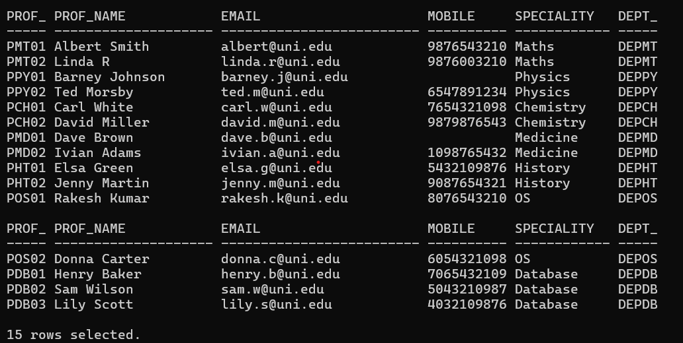

**-- SCHOOL Table**

select * from SCHOOL;

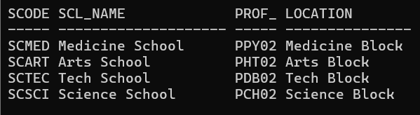

**-- DEPARTMENT Table**

select * from DEPARTMENT;

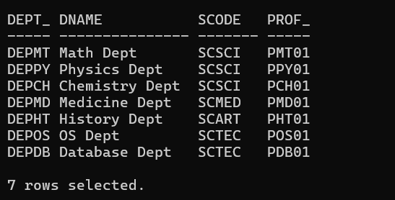

**-- COURSE Table**

select * from COURSE;

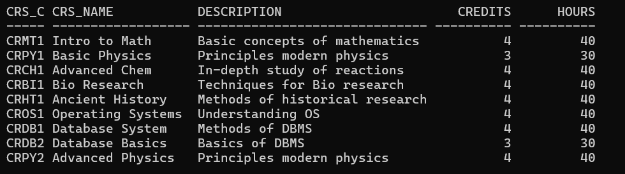

**-- SEMESTER Table**

select * from SEMESTER;

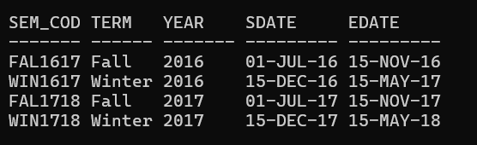

**-- CLASS Table**

select Cls_code, Slot, TO_CHAR(Stime, 'HH24:MI') AS Stime_HHMM, TO_CHAR(Etime, 'HH24:MI') AS Etime_HHMM, Crs_code, Prof_id, Room_no, Sem_code, Day_of_week, FROM CLASS;

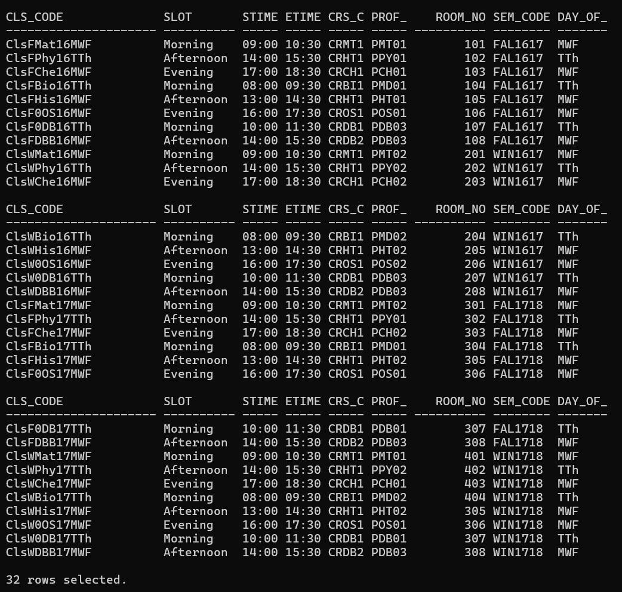

**-- STUDENT Table**

select * from STUDENT;

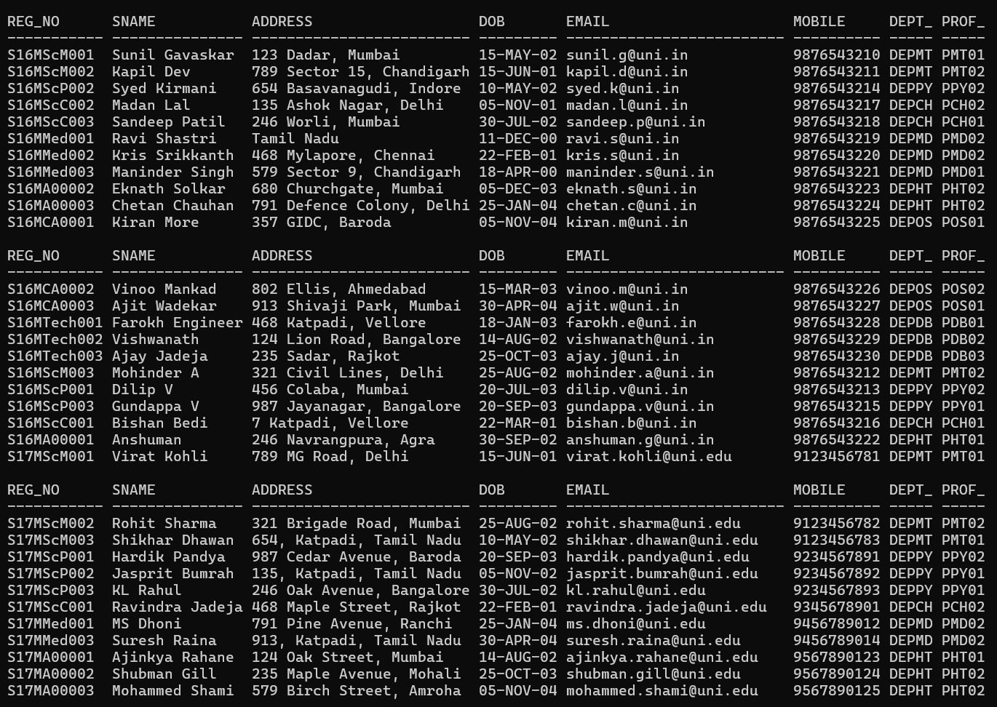

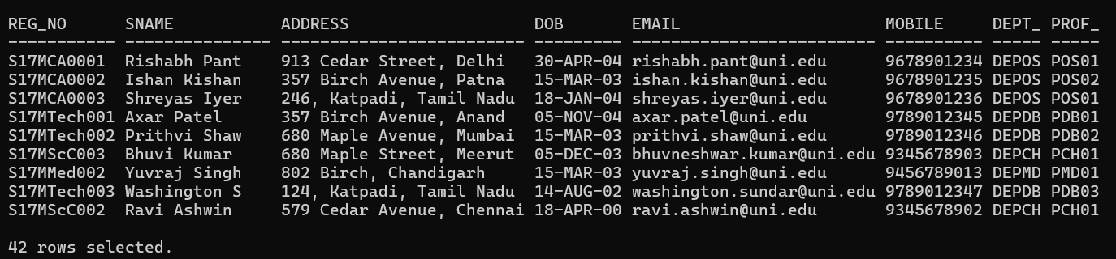

**-- ENROLL Table**

select Cls_code, Reg_no, TO_CHAR(Enroll_time, 'YYYY-MM-DD HH24:MI') AS Enroll_time, Grade FROM ENROLL;

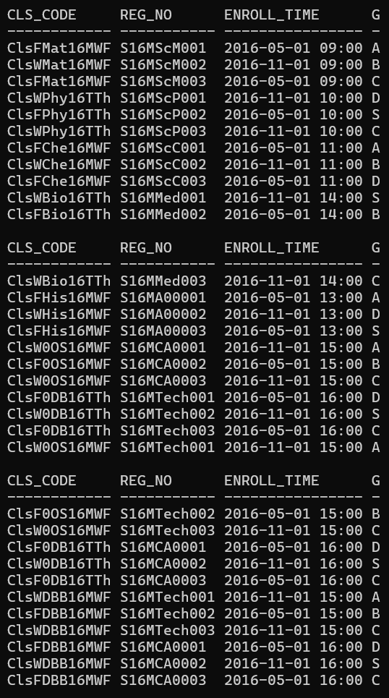

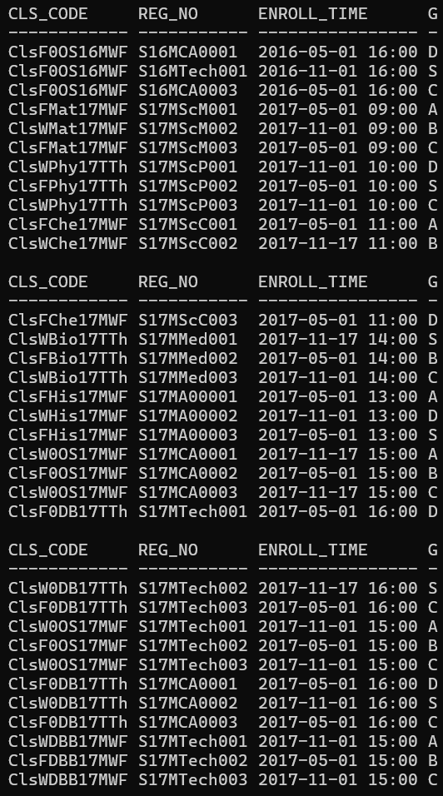

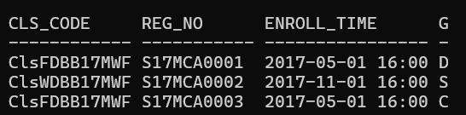

**-- STUDENT_VISA Table**

select * from STUDENT_VISA;

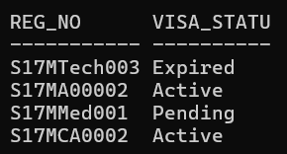

**-- PROGRAMME Table**

select * from PROGRAMME;

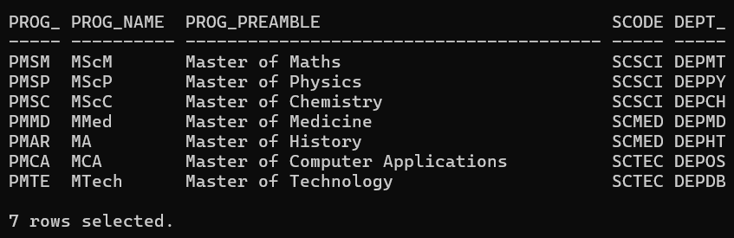

**--   Q4.**

**--(i) Test the string manipulation functions – UPPER, LOWER, INITCAP, LENGTH, LPAD, RPAD, LTRIM, RTRIM and TRIM, using select queries on data present in the tables. Use one query each for demonstration of one function.**

**--UPPER**

SELECT UPPER(Prof_Name) AS Uppercase_Name FROM PROFESSOR;

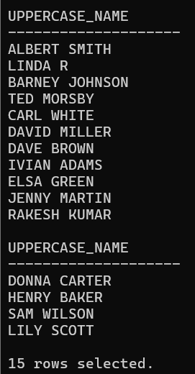

**--LOWER**

SELECT LOWER(Prof_Name) AS Lowercase_Name FROM PROFESSOR;

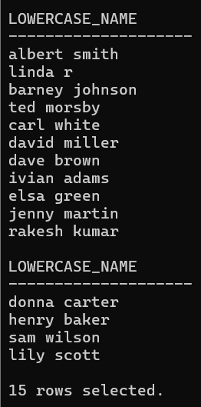

**--INITCAP**

SELECT INITCAP(Prof_Name) AS Initcap_Name FROM PROFESSOR;

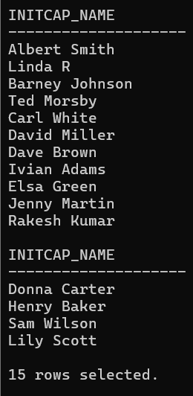

**--LENGTH**

SELECT Prof_Name, LENGTH(Prof_Name) AS Name_Length FROM PROFESSOR;

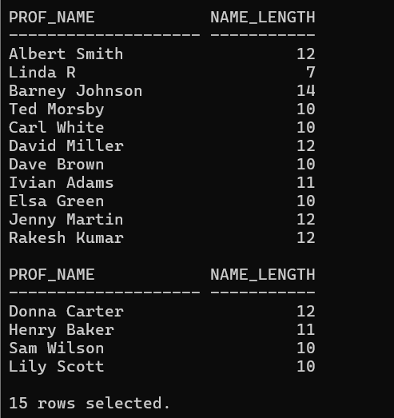

**--LPAD**

SELECT LPAD(Prof_Name, 15, '*') AS Lpad_Name FROM PROFESSOR;

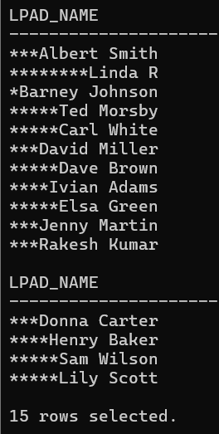

**--RPAD**

SELECT RPAD(Prof_Name, 15, '*') AS Rpad_Name FROM PROFESSOR;

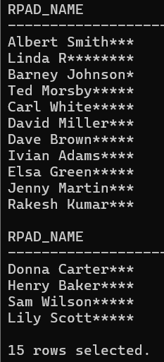

**--LTRIM**

SELECT LTRIM(Prof_Name, 'D') AS Ltrim_Name FROM PROFESSOR WHERE Prof_Name LIKE 'D%';

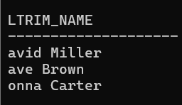

**--RTRIM**

SELECT RTRIM(Prof_Name, 'n') AS Rtrim_Name FROM PROFESSOR WHERE Prof_Name LIKE '%n';

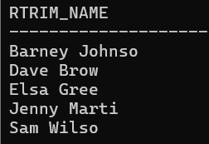

**--TRIM**

SELECT TRIM(' ' FROM Prof_Name) AS Trimmed_Name FROM PROFESSOR;

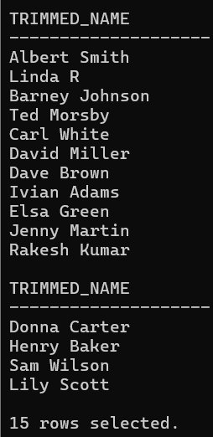

**--(ii) Write query to illustrate usage of NVL function and NULLIF function.**

**--NVL function**

SELECT Prof_id, NVL(Mobile, 'Not Provided') AS Mobile_Number FROM PROFESSOR;

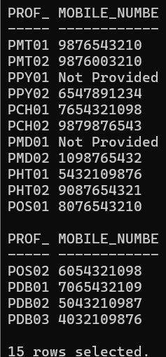

**--NULLIF function**

SELECT Cls_code, Slot, Day_of_week, NULLIF(Slot, Day_of_week) AS Slot_Check FROM CLASS;

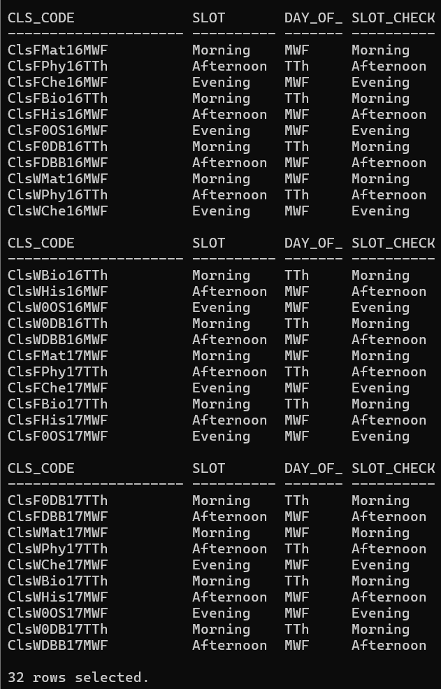

**--(iii) Display the name of the students who were born on a specified month.**

SELECT Sname FROM STUDENT WHERE TO_CHAR(DoB, 'MM') = '05';

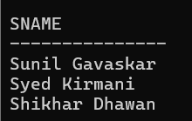

**--(iv) Display the name of the students with a specified date of birth.**

select Sname from STUDENT where DoB = TO_DATE('2004-01-25', 'YYYY-MM-DD');

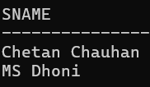

**--(v) Display the date of birth of a specified student in the format ‘Day of week, Month dd, yyyy’.**

SELECT Sname, TO_CHAR(DoB, 'Day, Month dd, yyyy') AS Formatted_DoB FROM STUDENT WHERE Sname = 'Virat Kohli';

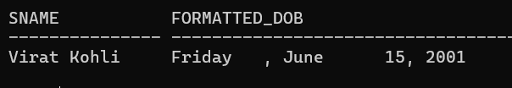

**--(vi) Display the hour and minutes of the start time and end time of a specified slot.**

SELECT Slot, TO_CHAR(Stime, 'HH24:MI') AS Start_Time_HHMM, TO_CHAR(Etime, 'HH24:MI') AS End_Time_HHMM FROM CLASS WHERE Slot = 'Morning' AND ROWNUM <= 5;

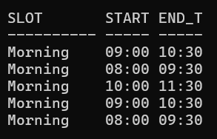

**--(vii) Display the day of week of the start date and end date of Winter semester 17–18.**

SELECT Sem_code, TO_CHAR(Sdate, 'Day') AS Start_Day, TO_CHAR(Edate, 'Day') AS End_Day, Year FROM SEMESTER WHERE Term = 'Winter' AND Year = '2017';



**--(viii) Display the duration of Winter semester 17–18 in terms of number of weeks.  || is used for string concatenation**

SELECT Term, ROUND((Edate - Sdate) / 7)||' Weeks' AS Duration_in_Weeks, Year FROM SEMESTER WHERE Term = 'Winter' AND Year = '2017';

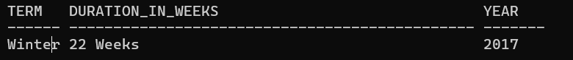

**--  Q5.**

**--(i) Display name, email address and address for those students who live in Katpadi area and whose name has an ‘s’ as the third character.**

select Sname, Email, Address from STUDENT where Address like '%Katpadi%' and Sname like '__s%';

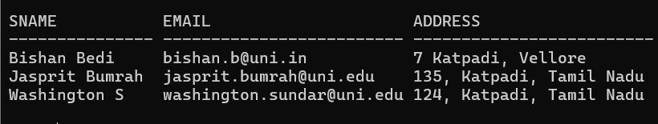

**--(ii) Display name, email address and address for those students who are not from Tamil Nadu.**

select Sname, Email, Address from STUDENT where Address like '%Tamil Nadu%';

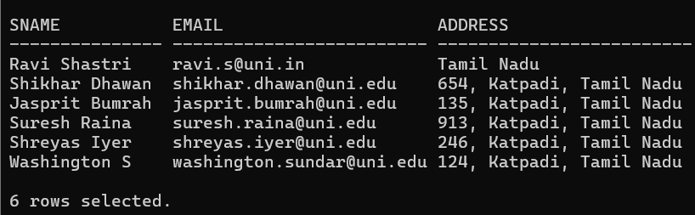

**--(iii) Display name, email address and address of foreign students only.**

SELECT S.Sname, S.Email, S.Address FROM STUDENT S INNER JOIN STUDENT_VISA SV ON S.Reg_no = SV.Reg_no;

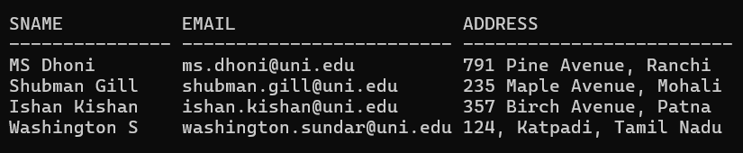

**--(iv) List the name of professors along with their specialty who belong to School of Medicine.**

SELECT P.Prof_id, P.Prof_name, P.Speciality FROM PROFESSOR P INNER JOIN DEPARTMENT D ON P.Dept_id = D.Dept_id INNER JOIN SCHOOL S ON D.SCode = S.SCode WHERE S.Scl_name = 'Medicine School';

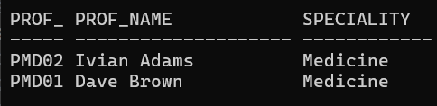

**--(v) Display name of the school and name of professor who chairs the school.**

select Scl_name, Prof_name from SCHOOL S, PROFESSOR P where S.Prof_id = P.Prof_id;

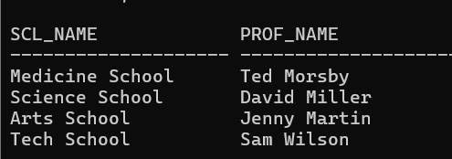

**--(vi) List course code, course name and course description in alphabetic order of course code.**

SELECT Crs_code, Crs_name, Description FROM COURSE ORDER BY Crs_code;

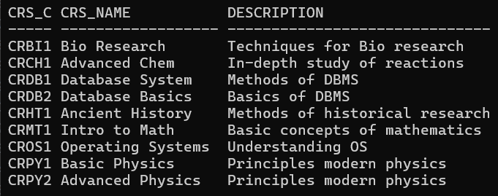

**--(vii) Change the mobile number of a student interactively.**

update STUDENT set Mobile= &Mobile where Reg_no='S17MScM001';

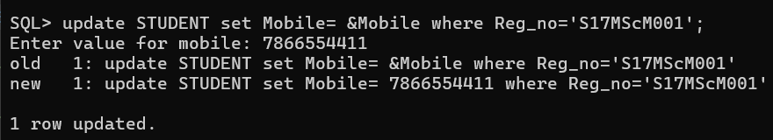

**--(viii) Remove enrollment information of a student from a particular course interactively. How would you recover the data?**

**--(ix) Create a duplicate of course table.**

create table copy_course as (select * from COURSE);

select * from copy_course;

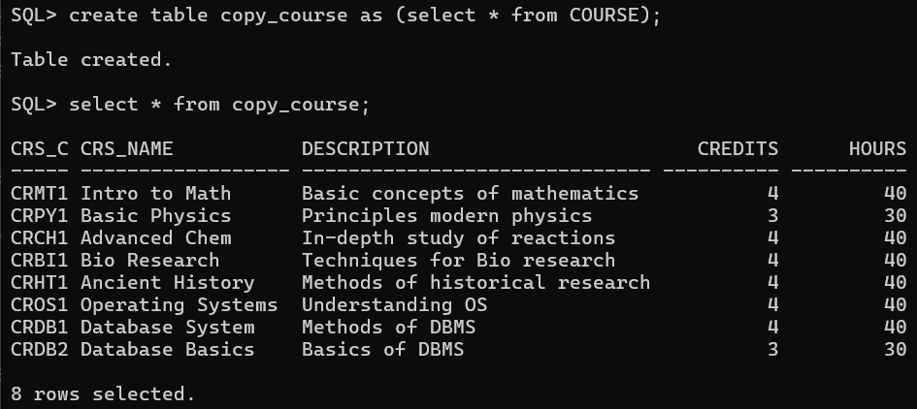

**--(x) Create a view for list of students (Reg_no, Sname) and the courses they have registered along with name of professors teaching the course.**

CREATE VIEW StudentCourseProfessor AS

SELECT S.Reg_no, S.Sname, C.Crs_name,

    (SELECT P.Prof_name

     FROM PROFESSOR P

     WHERE P.Prof_id = CL.Prof_id) AS Professor_name

FROM

    STUDENT S, ENROLL E, CLASS CL, COURSE C

WHERE

    S.Reg_no = E.Reg_no

    AND E.Cls_code = CL.Cls_code

    AND CL.Crs_code = C.Crs_code;

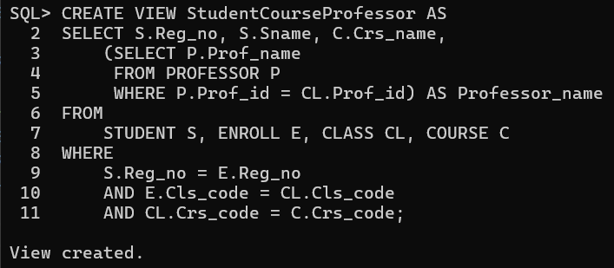

**--(xi) List the room number, slot, start time, end time and duration of every class held on Wednesdays in descending order of room number.**

SELECT Room_no, Slot, TO_CHAR(Stime, 'HH:MI') AS Start_time, TO_CHAR(Etime, 'HH:MI') AS End_time,

    EXTRACT(HOUR FROM (Etime - Stime)) || ' hr ' || EXTRACT(MINUTE FROM (Etime - Stime)) || ' min' AS Duration

FROM Class WHERE Day_of_week LIKE '%W%' ORDER BY Room_no DESC;

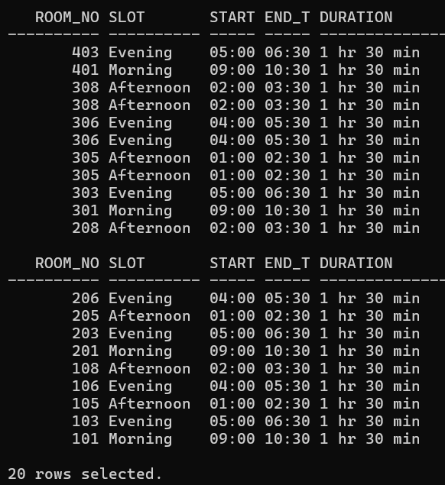

**--(xii) Display the name and grade of a student in different courses underwent in fall semester 2017 – 18.**

SELECT s.Sname, e.Grade

FROM STUDENT s, ENROLL e, CLASS cl, SEMESTER sem

WHERE s.Reg_no = e.Reg_no

  AND e.Cls_code = cl.Cls_code

  AND cl.Sem_code = sem.Sem_code

  AND sem.Term= 'Fall'

  AND sem.Year = '2017';

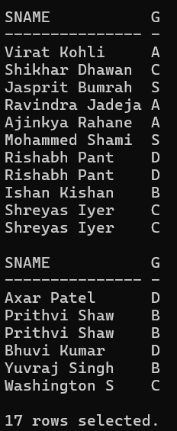

**--(xiii) Find out name of students who have taken Database Systems course as well as Operating Systems course in fall semester 2016 – 17.**

SELECT S.Sname

FROM STUDENT S, ENROLL E, CLASS CL, COURSE C, SEMESTER SEM

WHERE S.Reg_no = E.Reg_no

    AND E.Cls_code = CL.Cls_code

    AND CL.Crs_code = C.Crs_code

    AND CL.Sem_code = SEM.Sem_code

    AND SEM.Term = 'Fall'

    AND SEM.Year LIKE '2016'

    AND (C.Crs_name = 'Database System' OR C.Crs_name = 'Operating Systems')

GROUP BY S.Sname

HAVING COUNT(DISTINCT C.Crs_name) = 2;

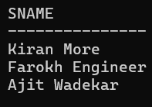

**--(xiv) Find out name of students who have taken Database Systems course but have not taken Operating Systems course in winter semester 2017 – 18**

SELECT s.Reg_no, Sname, e.Cls_code FROM STUDENT s, ENROLL e, CLASS cls, COURSE crs, SEMESTER sem

    WHERE s.Reg_no = e.Reg_no

    AND e.Cls_code = cls.Cls_code

    AND cls.Crs_code = crs.Crs_code

    AND cls.Sem_code = sem.Sem_code

    AND sem. Term = 'Winter'

    AND sem.Year LIKE '2017'

    AND (crs.Crs_name LIKE 'Database System')

    AND s.Reg_no NOT IN (

        SELECT s2.Reg_no

        FROM STUDENT s2, ENROLL e2, CLASS cls2, COURSE crs2, SEMESTER sem2

        WHERE s2.Reg_no = e2.Reg_no

        AND e2.Cls_code = cls2.Cls_code

        AND cls2.Crs_code = crs2.Crs_code

        AND cls2.Sem_code = sem2.Sem_code

        AND sem2. Term = 'Winter'

        AND sem2.Year LIKE '2017'

        AND crs2.Crs_name LIKE 'Operating Systems%'

    );

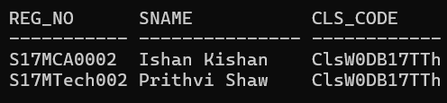

**--(xv) List the registration number and name of the students who have registered for maximum number of credits in Winter 17-18 semester.**

SELECT s.Reg_no, s.Sname, SUM(crs.Credits) AS Total_Credits

FROM STUDENT s, ENROLL e, CLASS cls, COURSE crs, SEMESTER sem

WHERE s.Reg_no = e.Reg_no

    AND e.Cls_code = cls.Cls_code

    AND cls.Crs_code = crs.Crs_code

    AND cls.Sem_code = sem.Sem_code

    AND sem. Term = 'Winter'

    AND sem.Year LIKE '2017'

GROUP BY s.Reg_no, s.Sname

HAVING SUM(crs.Credits) = (

    SELECT MAX(SUM(crs2.Credits))

    FROM STUDENT s2, ENROLL e2, CLASS cls2, COURSE crs2, SEMESTER sem2

    WHERE s2.Reg_no = e2.Reg_no

        AND e2.Cls_code = cls2.Cls_code

        AND cls2.Crs_code = crs2.Crs_code

        AND cls2.Sem_code = sem2.Sem_code

        AND sem2. Term = 'Winter'

        AND sem2.Year LIKE '2017'

    GROUP BY s2.Reg_no

);

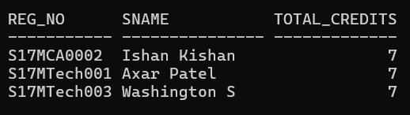

**--(xvi) List the name of the course and the number of students registered in each slot for course under different faculty members.**

SELECT c.Crs_name, cl.Slot, p.Prof_name, COUNT(e.Reg_no) AS No_of_Students

FROM COURSE c, CLASS cl, PROFESSOR p, ENROLL e

WHERE c.Crs_code = cl.Crs_code

    AND cl.Prof_id = p.Prof_id

    AND cl.Cls_code = e.Cls_code

GROUP BY c.Crs_name, cl.Slot, p.Prof_name

ORDER BY c.Crs_name, cl.Slot, p.Prof_name;

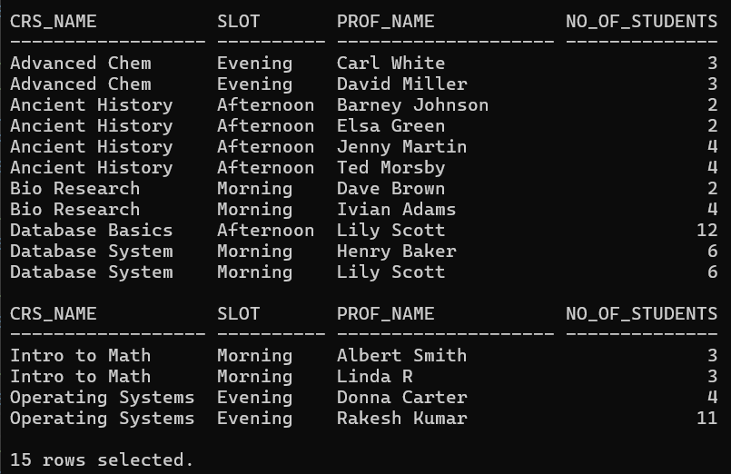

**--(xvii) Find out the name of the students who have registered in all the courses being taught by Prof. OBrien in Winter 17-18.**

SELECT S.Sname

FROM STUDENT S, ENROLL E, CLASS Cls, COURSE Crs, PROFESSOR P, SEMESTER Sem

WHERE S.Reg_no = E.Reg_no

    AND E.Cls_code = Cls.Cls_code

    AND Cls.Crs_code = Crs.Crs_code

    AND Cls.Prof_id = P.Prof_id

    AND Cls.Sem_code = Sem.Sem_code

    AND Sem.Term = 'Winter'

    AND Sem.Year LIKE '2017'

    AND P.Prof_name LIKE 'Lily Scott'

GROUP BY S.Sname

HAVING COUNT(E.Cls_code) = (

    SELECT COUNT(Cls.Cls_code)

    FROM CLASS Cls, PROFESSOR P, SEMESTER Sem

    WHERE Cls.Prof_id = P.Prof_id

        AND Cls.Sem_code = Sem.Sem_code

        AND Sem.Term = 'Winter'

        AND Sem.Year LIKE '2017'

        AND P.Prof_name LIKE 'Lily Scott'

);

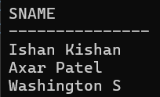

**--(xviii) List the registration number of the students who registered in Database Systems course on November 17, 2017**

select S.Reg_no from STUDENT S, ENROLL E, CLASS Cl, COURSE C

where

    S. Reg_no =  E.Reg_no and

    E.Cls_code = Cl.Cls_code and

    Cl.Crs_code = C.Crs_code

and

    TO_CHAR(E.Enroll_time, 'YYYY-MM-DD') LIKE '2017-11-17' and

    Crs_name = 'Database System';

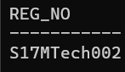

**--(xix) Write a query to display the grade of a student given his/her registration number and the course name for Fall semester 17–18.**

--S001

--Intro to Math

SELECT E.Grade

FROM ENROLL E, CLASS Cls, COURSE Crs, SEMESTER Sem

WHERE E.Cls_code = Cls.Cls_code

    AND Cls.Crs_code = Crs.Crs_code

    AND Cls.Sem_code = Sem.Sem_code

    AND Sem.Term = 'Fall'

    AND Sem.Year = '2017'

    AND E.Reg_no = '&reg_no'

    AND Crs.Crs_name = '&Crs_name';

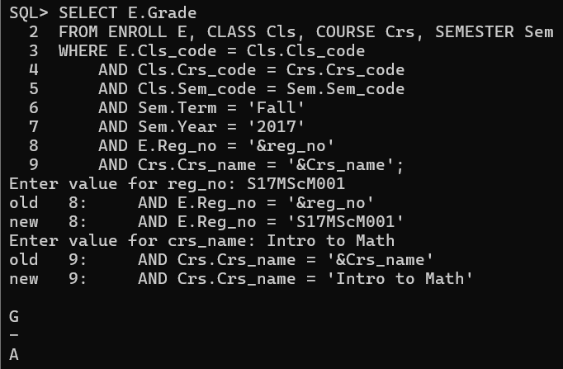

**--(xx) List the name of departments and the name professors who is in charge of the department.**

SELECT D.Dname, P.Prof_name FROM DEPARTMENT D, PROFESSOR P WHERE D.Prof_id = P.Prof_id;

--(xxi) List the name of schools with students’ strength higher than 7000.

SELECT S.Scl_name from SCHOOL S, STUDENT St, DEPARTMENT D

where

    S.SCode = D.SCode and

    St.Dept_id = D.Dept_id

group by

    S.Scl_name

having

    count(*) > 10;

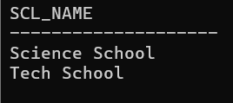

**--(xxii) List the name of the department(s) under school of medicine with student strength higher than the average students of all the departments in the school.**

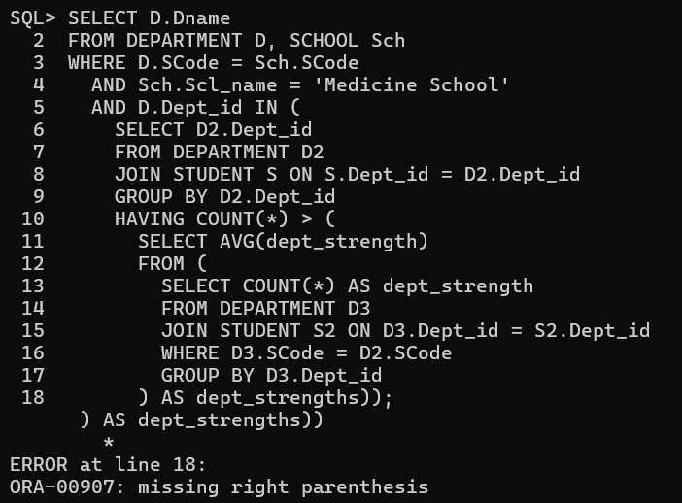

**--xxiii) Given the registration number of a student, display the total credits registered by him/her in Winter 17–18.**

select sum(Credits) from ENROLL E, CLASS Cl, COURSE C, SEMESTER S

where

    E.Cls_code = Cl.Cls_code and

    Cl.Crs_code = C.Crs_code and

    Cl.Sem_code = S.Sem_code and

    E.Reg_no = 'S17MTech001' and

    S.Year = '2017' and

    Term = 'Winter';

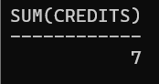

**--(xxiv) Given the registration number of a student, display her/his grade in the course she/he registered in Fall 17–18.**

select C.Crs_name, E.Grade from ENROLL E, CLASS Cl, COURSE C, SEMESTER S

where

    E.Cls_code = Cl.Cls_code and

    Cl.Crs_code = C.Crs_code and

    Cl.Sem_code = S.Sem_code and

    E.Reg_no = 'S17MCA0001' and

    S.Year = '2017' and

    S.Term = 'Fall';

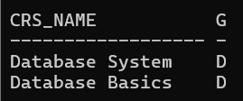

**--(xxv) Display the name of the courses that are not being offered in Winter 17–18.**

SELECT Crs_name

FROM COURSE

WHERE Crs_name NOT IN (

    SELECT C.Crs_name

    FROM COURSE C, CLASS Cl, SEMESTER S

    WHERE

        C.Crs_code = Cl.Crs_code

        AND Cl.Sem_code = S.Sem_code

        AND S.Year = '2017'

        AND S.Term = 'Winter'

);

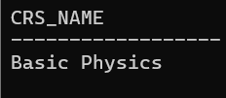

**--(xxvi) Write necessary SQL statement to advance the start time and end time of every class by ten minutes in Fall 17-18.**

UPDATE CLASS

SET

    Stime = Stime + INTERVAL '10' MINUTE,

    Etime = Etime + INTERVAL '10' MINUTE

WHERE

    Cls_code IN (

        SELECT Cl.Cls_code

        FROM COURSE C, CLASS Cl, SEMESTER S

        WHERE

            C.Crs_code = Cl.Crs_code

            AND Cl.Sem_code = S.Sem_code

            AND S.Year = '2017'

            AND S.Term = 'Fall'

    );

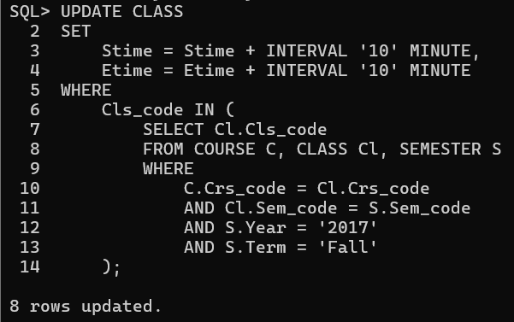

**--(xxvii) Write necessary SQL statement to advance the start date and end date of Fall 16–17 semester by one week with respect to Fall semester of 17 – 18.**

UPDATE SEMESTER

SET

    Sdate = (SELECT Sdate + INTERVAL '7' DAY

             FROM SEMESTER

             WHERE Term = 'Fall' AND Year = '2017'),

    Edate = (SELECT Edate + INTERVAL '7' DAY

             FROM SEMESTER

             WHERE Term = 'Fall' AND Year = '2017')

WHERE

    Term = 'Fall'

    AND Year = '2016';

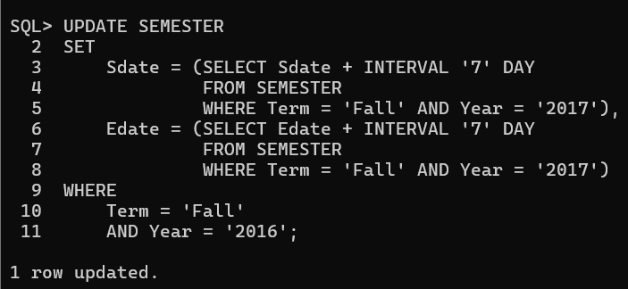

**--(xxviii) Find out the name list of students who had secured ‘S’ grade in at least 50% of the courses cleared by her/him**

SELECT S.Sname

FROM STUDENT S

WHERE

    (SELECT COUNT(*)

     FROM ENROLL E

     WHERE E.Reg_no = S.Reg_no AND E.Grade = 'S') >=

    (SELECT COUNT(*) / 2

     FROM ENROLL E

     WHERE E.Reg_no = S.Reg_no);

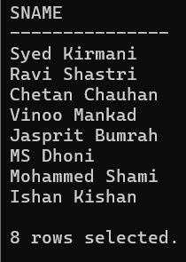

**--(xxix) Given the registration number of a student, find out his/her free slots.**

SELECT DISTINCT Cl.Slot

FROM CLASS Cl

WHERE Cl.Slot NOT IN (

    SELECT C.Slot

    FROM ENROLL E

    JOIN CLASS C ON E.Cls_code = C.Cls_code

    WHERE E.Reg_no = 'S17MScM003'

);

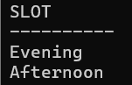

**--(xxx) Find out the name list of students who have classes in the afternoon session only a specific day of the week.**

SELECT S.Sname

FROM STUDENT S

WHERE NOT EXISTS (

    SELECT 1

    FROM ENROLL E

    JOIN CLASS C ON E.Cls_code = C.Cls_code

    WHERE E.Reg_no = S.Reg_no

    AND C.Day_of_week LIKE '%W%'

    AND C.Slot NOT LIKE 'Afternoon'

)

AND EXISTS (

    SELECT 1

    FROM ENROLL E

    JOIN CLASS C ON E.Cls_code = C.Cls_code

    WHERE E.Reg_no = S.Reg_no

    AND C.Day_of_week LIKE '%W%'

    AND C.Slot LIKE 'Afternoon'

);

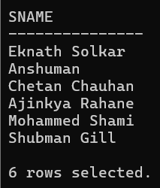

**--(xxxi) Add a column named ‘Duration’ (to indicate duration of a class) with appropriate data type to the CLASS table and populate the column from values of start time and end time columns.**

ALTER TABLE CLASS ADD Duration VARCHAR2(7);

UPDATE CLASS

SET Duration = TO_CHAR(EXTRACT(HOUR FROM (Etime - Stime)), 'FM00') || ':' ||

               TO_CHAR(EXTRACT(MINUTE FROM (Etime - Stime)), 'FM00');

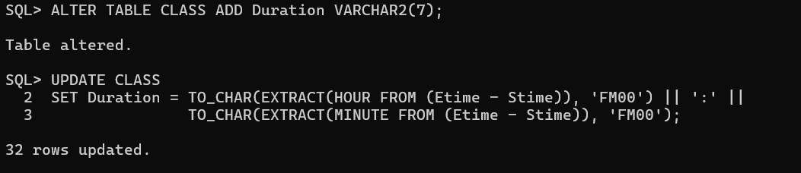

**--(xxxii) Add a column named ‘SemesterDuration’ (indicating duration of a semester) with appropriate data type to the SEMESTER table and populate the column from values of start date and end date columns.**

ALTER TABLE SEMESTER ADD SemesterDuration NUMBER(1);

UPDATE SEMESTER SET SemesterDuration = ROUND(MONTHS_BETWEEN(Edate, Sdate));

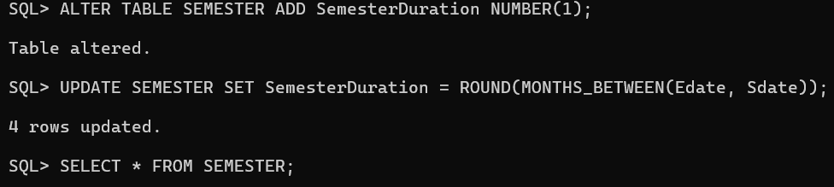

**--(xxxiii) Find out the list of students who are undergoing MCA program.**

SELECT S.Sname FROM STUDENT S, PROGRAMME P WHERE S.Dept_id = P.Dept_id AND P.Prog_name = 'MCA';

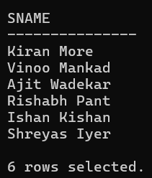

**--(xxxiv) Display the name of programs and the name of school offering the program.**

SELECT Prog_name, Scl_name FROM PROGRAMME P, SCHOOL S WHERE P.SCode = S.SCode;

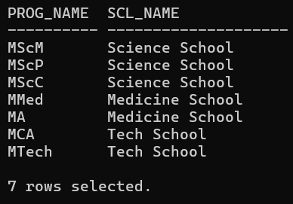

**--(xxxv) Display the name of the departments and the name of the program controlled by the department.**

SELECT Dname, Prog_name FROM DEPARTMENT D, PROGRAMME P WHERE D.Dept_id = P.Dept_id;

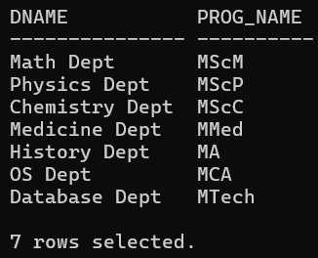

**--(xxxvi) Find the school which has highest school strength (i.e number of students)**

SELECT Scl_name

FROM (

    SELECT Sch.Scl_name

    FROM SCHOOL Sch

    JOIN DEPARTMENT D ON Sch.SCode = D.SCode

    JOIN STUDENT S ON D.Dept_id = S.Dept_id

    GROUP BY Sch.Scl_name

    ORDER BY COUNT(S.Reg_no) DESC

)

WHERE ROWNUM = 1;

